**Phase 2: Org Setup & Configuration**

**Step 1: Company Information Setup**

From your shared data:

1. **Organization Name:** salesforce → leave as-is or update to FinTrust CRM for clarity.
2. **Primary Contact:** Kotha Sree Jyothirmai → correct.
3. **Locale & Time Zone:**
   * Default Locale: English (India)
   * Default Time Zone: (GMT+05:30) India Standard Time (Asia/Kolkata)
4. **Default Currency:** INR

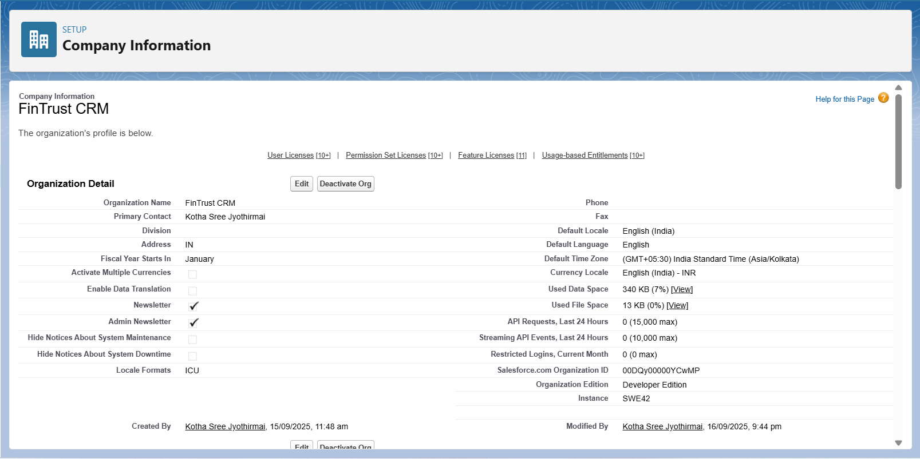

**Step 2: Business Hours**

Go to Setup → search for Business Hours in the Quick Find.

In standard business hours set;

* **Business Hours Name:** Default
* **Use these business hours as the default:** Check
* **Active:** Check
* **Time Zone:** (GMT+05:30) India Standard Time (Asia/Kolkata)

Ensures all business hours and case escalations follow Indian Standard Time.

* Set **9:00 am to 6:00 pm**.

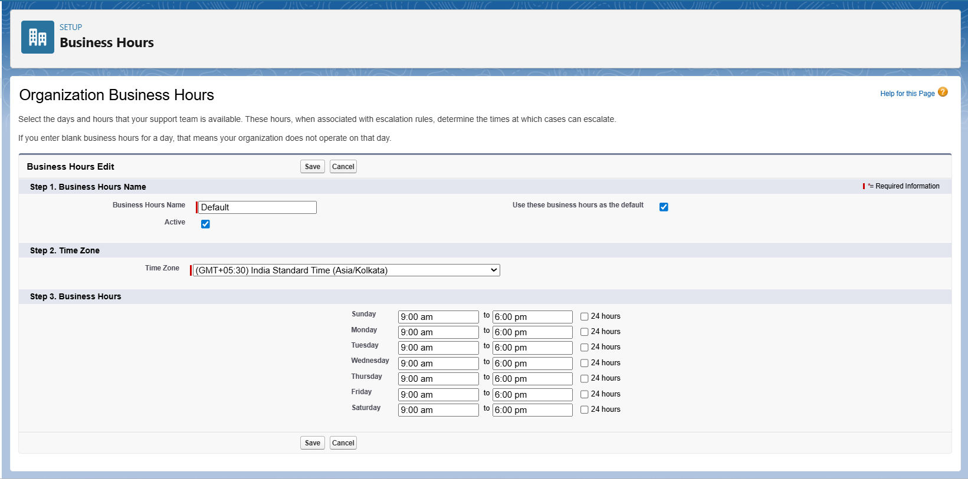

**Step 3:Fiscal Year Setup – Step by Step**

1. **Navigate to Fiscal Year Setup**
   * Path: Setup → Fiscal Year.
2. **Choose Fiscal Year Type**
   * Select **Standard Fiscal Year** (Jan–Dec) **or** **Custom Fiscal Year** if months differ.
3. **Configure Start Month**
   * Select the starting month (e.g., **January**).
4. **Save**

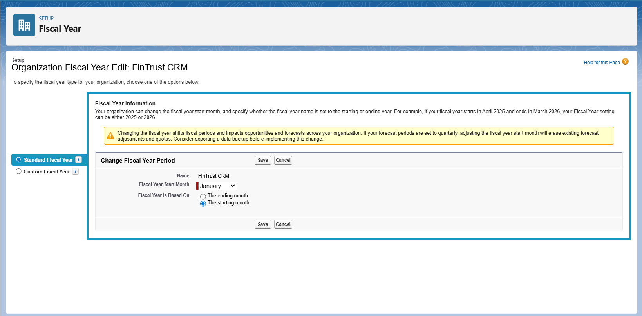

**Step 4:Holidays**

**1. Navigate to Holidays**

1. Go to **Setup** → search for **Holidays** in the Quick Find box → click **Holidays**.

**2. Create a New Holiday**

1. Click **New Holiday**.
2. Fill in the fields:

Ex:

| **Field** | **Example / Instruction** |
| --- | --- |
| **Holiday Name** | Republic Day |
| **Description** | National holiday - India (optional) |
| **Start Date** | 26/01/2026 (choose your date) |
| **End Date** | Same as Start Date if single day |
| **Recurrence** | Check if this holiday occurs every year (optional) |
| **Active** | Checked |

* Click **Save**.

3. Repeat for Other Holidays

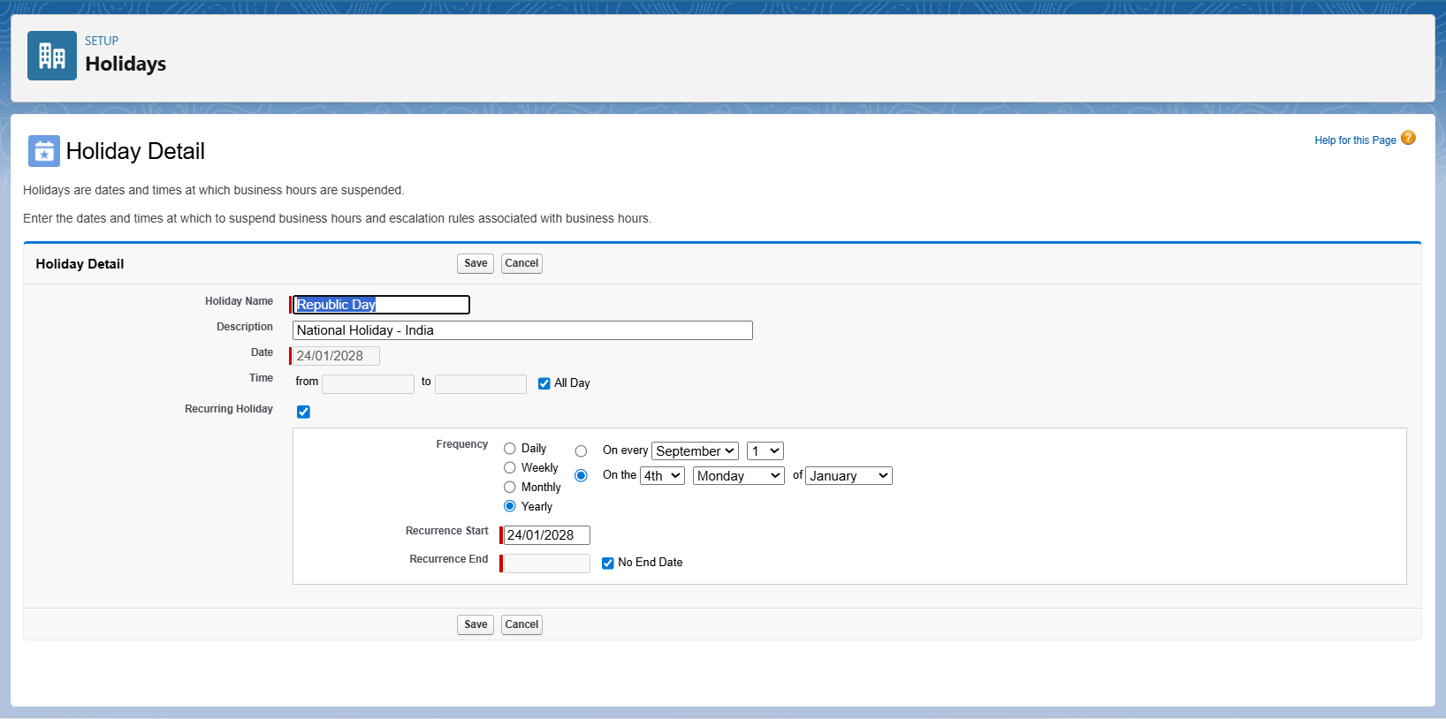

**Step 5:Roles Setup**

* Go to Setup → search Roles in Quick Find.
* Click Set Up Roles.
* Click Expand All to view the hierarchy**.**
* Create the final hierarchy

**CEO**

**└─ Manager**

**├─ Loan Officer**

**└─ Customer Service**

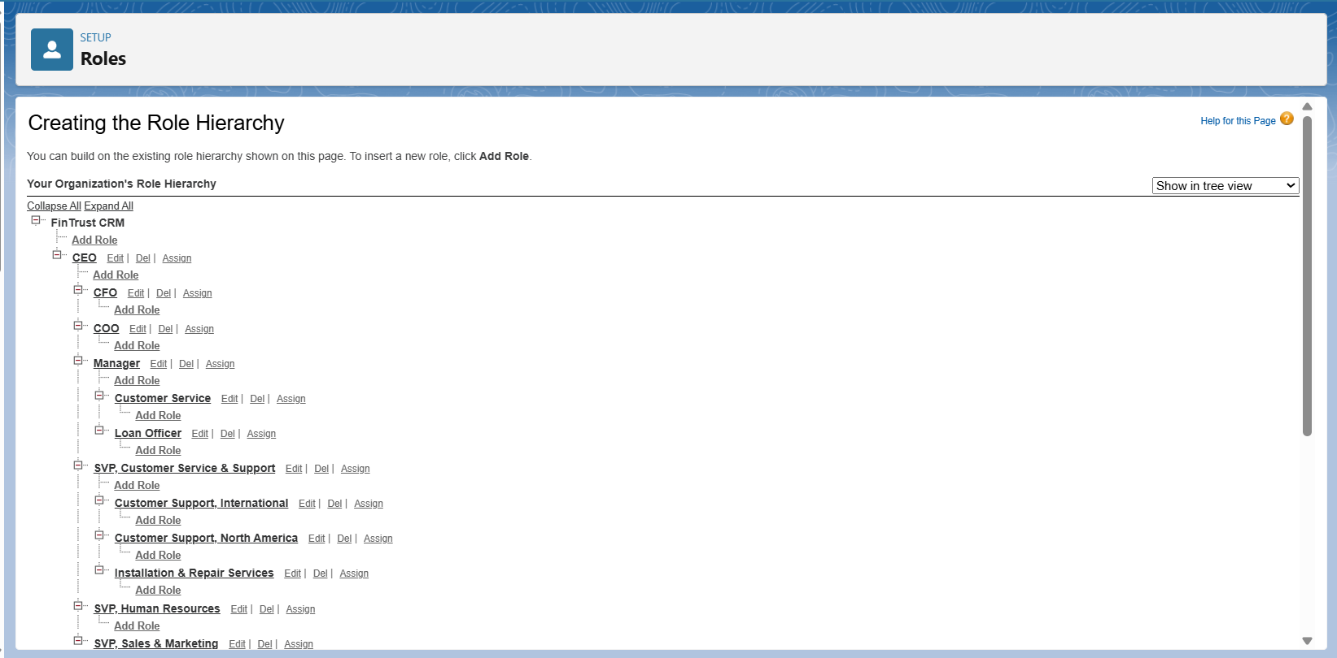

**Step 6: Profiles setup**

1. Create Custom Profiles

1. Go to Setup → Profiles.
2. Find Standard User profile / custom: sales profile.
3. Click Clone → rename it for each role:
   * Officer Profile
   * Manager Profile
   * Customer Service Profile
4. Save each profile**.**

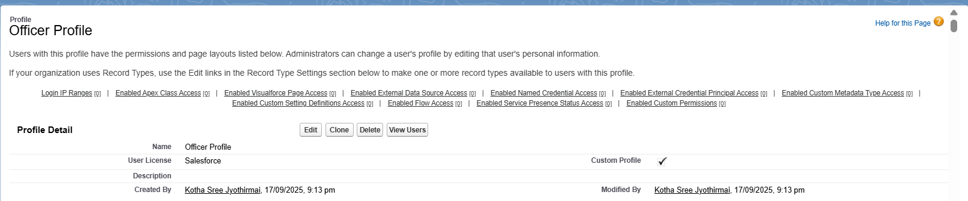

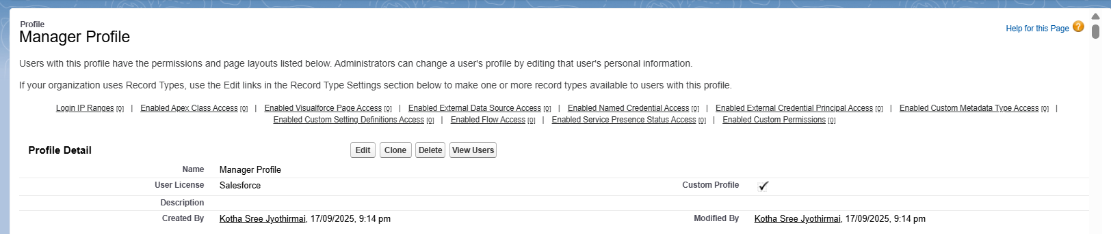

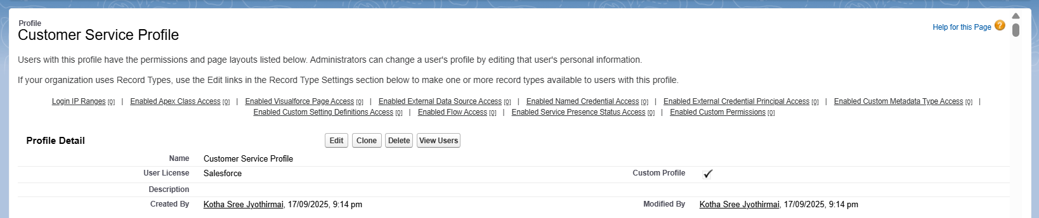

**Step 7: Create Custom Objects**

1. Go to Setup → Object Manager.
2. Click Create → Custom Object.
3. Fill details:
   * Label: Loan Application
   * Object Name: Loan_Application
   * Plural Label: Loan Applications
   * Save.
4. Repeat for:
   * Label: EMI
   * Object Name: EMI
   * Plural Label: EMIs
   * Save

**Step 8: Assign Object Permissions**

1. Open the Profile Name you created.
2. Go to Object Settings.
3. Set permissions:
   * Loan_Application__c → ✅Read, Create, Edit, Delete
   * EMI__c → ✅ Read, Create, Edit (No Delete)
4. Scroll down to Administrative Permissions → Enable:
   * Run Reports
   * Export Reports
5. Click Save.

**Step 9: Permission Sets**

Use Permission Sets for additional access without changing the profile.

1. Go to Setup → Permission Sets.
2. Click New.
3. Enter details:
   * Label: Loan Management Access
   * License: Salesforce Platform
4. Save.
5. Add permissions you need (e.g., API Enabled, Export Reports).
6. Assign to users as required.

**Step 10: Create a Users**

Go to Setup → Users → Users → New User.

1. Fill in details:
   * First Name / Last Name: Ravi Kumar
   * Alias: rkumar
   * Email: ravi.kumar@demo.com (any valid email, even your secondary email works)
   * Username: must be unique across Salesforce, e.g. rkumar.demo@loancrm.com
   * User License: Salesforce
   * Profile: Officer Profile
   * Check Active ✅
2. Save.

Repeat for Manager & Customer Service

* Create another user with Manager Profile.
* Create another user with Customer Service Profile.

(or)

* Setup → **Users** → New Users as loan officer, manager, customer service.
  + Loan Officer → loan.officer@fintrust.dev (assign Officer Profile + Role).
  + Manager → manager@fintrust.dev (assign Manager Profile + Role).
  + Customer Service → customer.service@fintrust.dev (assign Customer Service Profile + Role).

**Step 10: Understand Org-Wide Defaults (OWD)**

Org-Wide Defaults control the baseline level of access users have to each object’s records.

* Setup → Sharing Settings
* Scroll to **Organization-Wide Defaults.**
* Click **Edit.**
  + Loan_Application__c = Private
  + Contact = Public Read Only
  + EMI_c=private

Save.

**Step 11:** **Sharing Rules**

Since Loan_Application__c,EMI_c is private, some users like Managers or Loan Officers may need access to other users’ loan records.

Sharing Rules allow you to grant additional access beyond OWD:

* You can share by:
  + Role (e.g., all Managers see all Loan Applications)
  + Public Groups (a set of users)
  + Criteria (e.g., all loan applications with status “Pending”)

| **Sharing Rule** | **What it does** |
| --- | --- |
| Manager Sharing | Managers can view/edit all Loan Applications in their branch. |
| Officer Sharing | Loan Officers can view all Loan Applications in their role group. |

**Create Sharing Rules**

1. Go to **Setup → Sharing Settings**.
2. Scroll to **Loan_Application__c Sharing Rules**.
3. Click **New Sharing Rule**.
4. Choose **Rule Type**:
   * **Based on Role** (common for Managers/Officers)
5. Define **Access Level**:
   * Read/Write (if they should edit records)
   * Read Only (if they only need to view)
6. Save the rule and **run the sharing recalculation** (Salesforce automatically propagates access).

7. Do same for EMI_c.



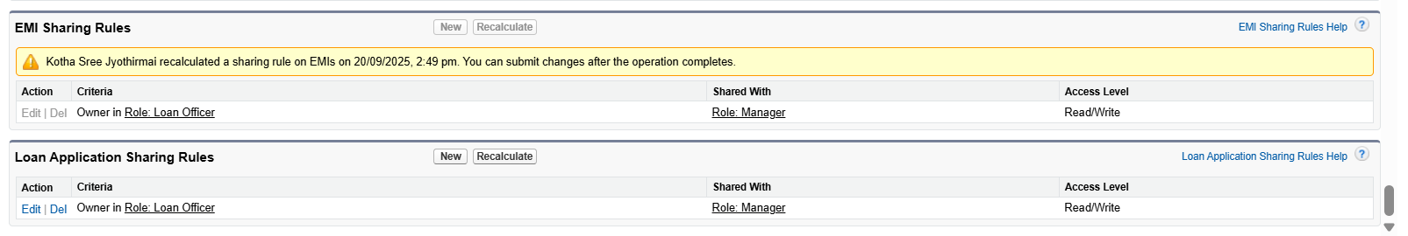

**Step 12: Assign the Permission Set to Users**

1. Still inside the Permission Set → Manage Assignments
2. Click Add Assignments
3. Select:
   * Loan Officer
   * Manager
   * Customer Service
4. Save

